**1. INTRODUCTION:**

**1.1 Overview**

* **Description of the project**

**Project Description:**

**Dream Homes Realty, a construction company, uses Zoho Books to track project expenses, manage subcontractor payments, and handle invoicing. They can generate estimates and invoices for clients, track job costing, and monitor the profitability of each project. Zoho Books provides them with financial insights to make informed decisions**

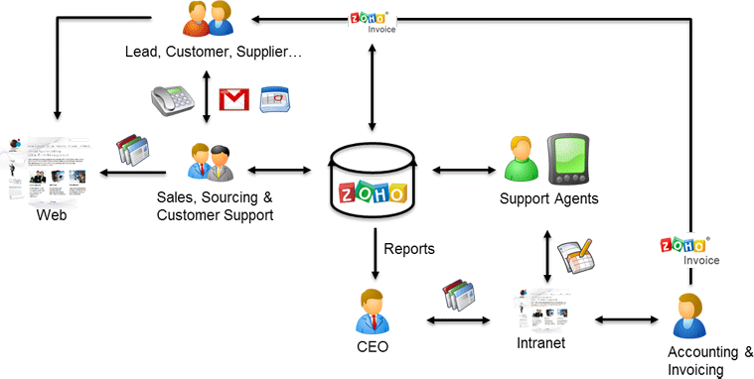

**2. Problem definition & design Thinking**

**2.1 Empathy map:**

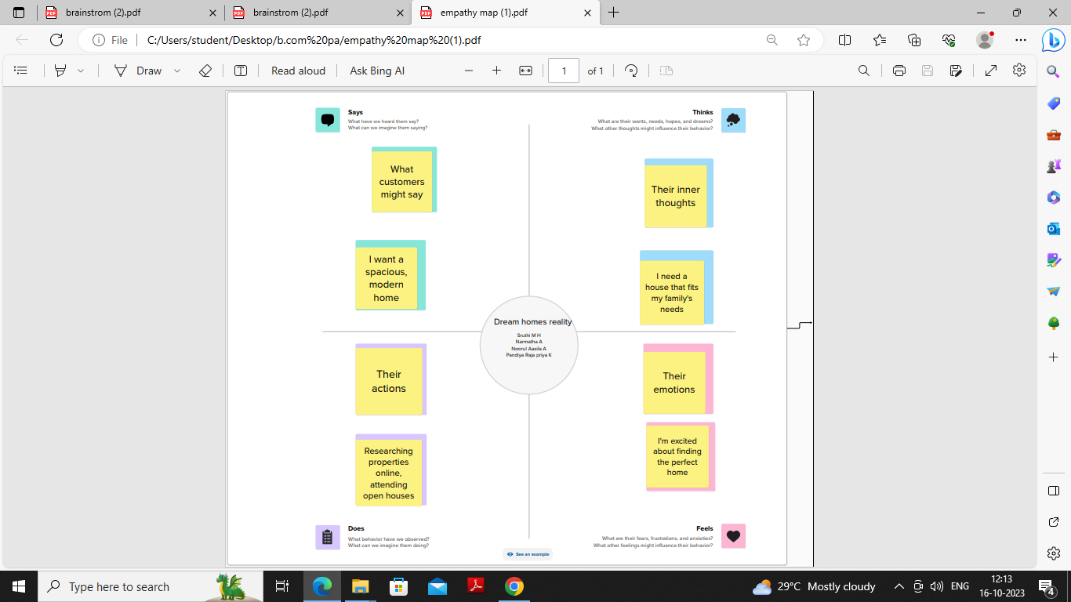

**2.2 Ideation & Brainstorming map:**

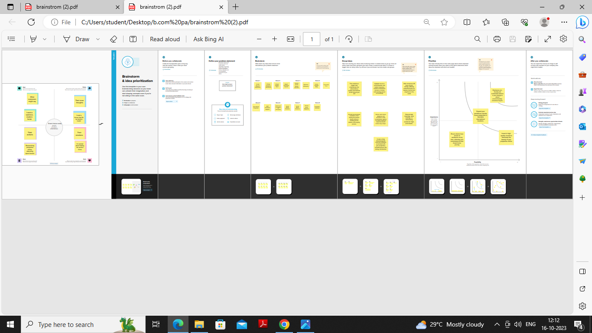

**3. Result**

**Profit&Loss:**

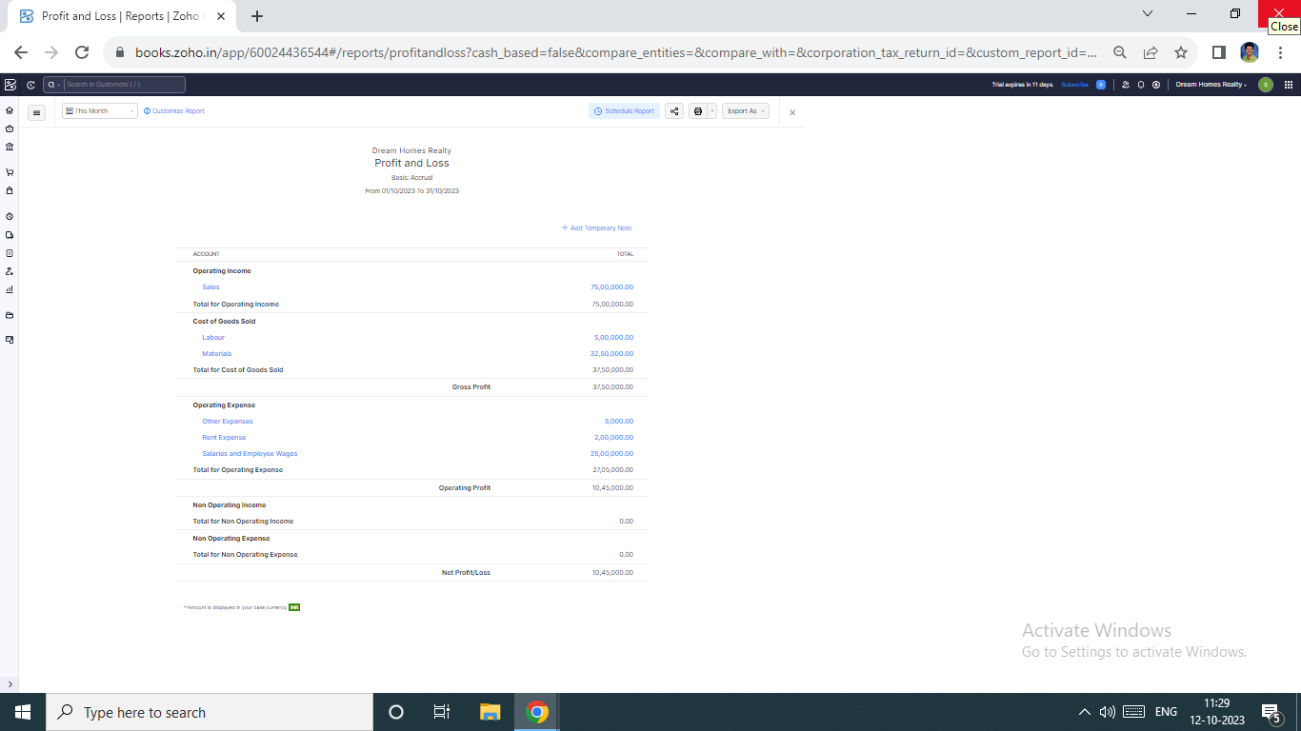

**Balance Sheet:**

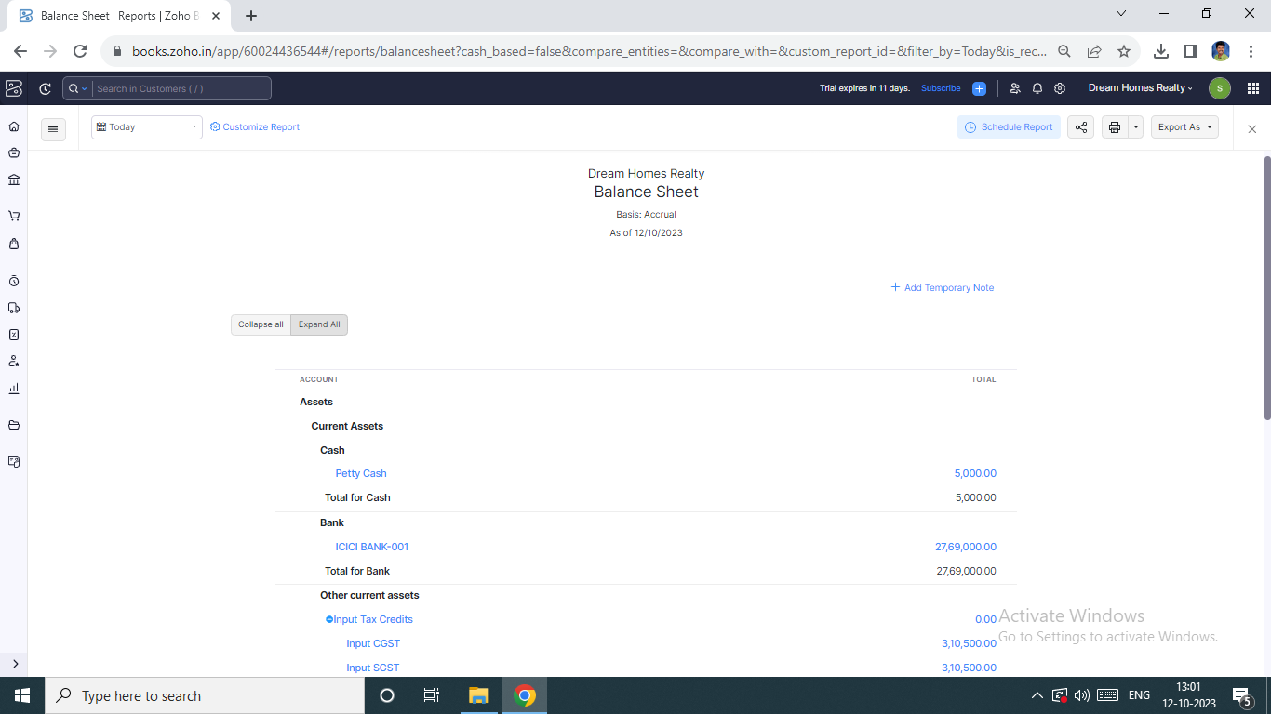

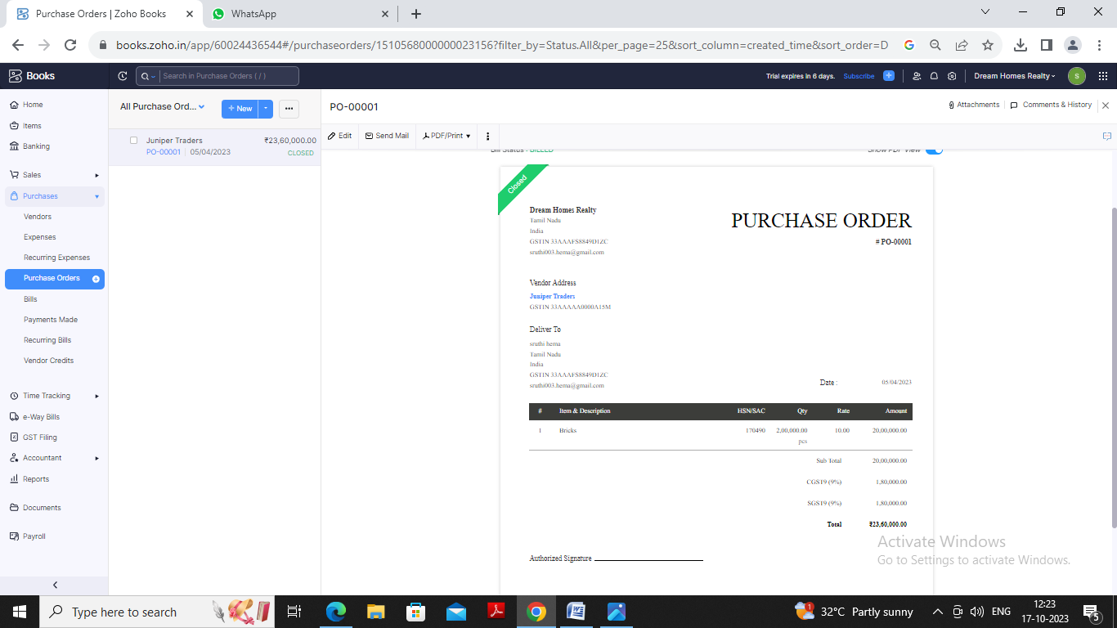**Purchase Order:**

**Sales Order:**

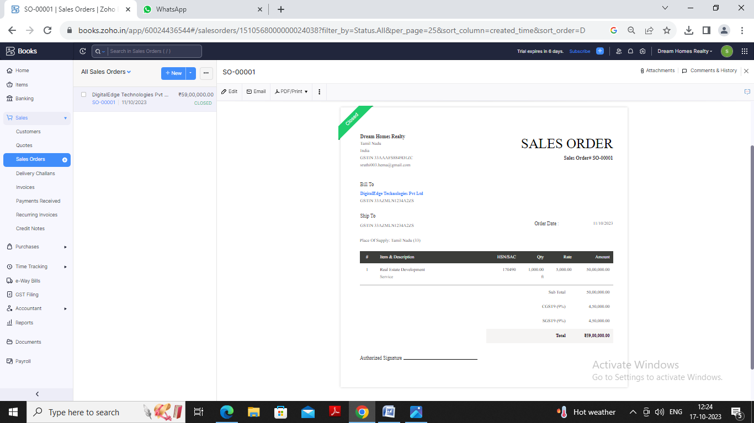

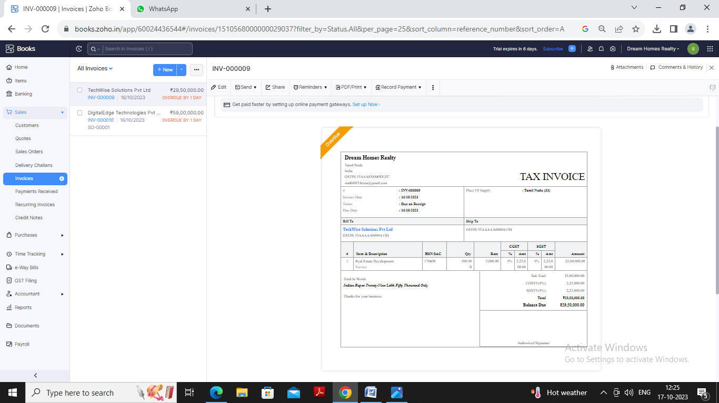**Invoice:**

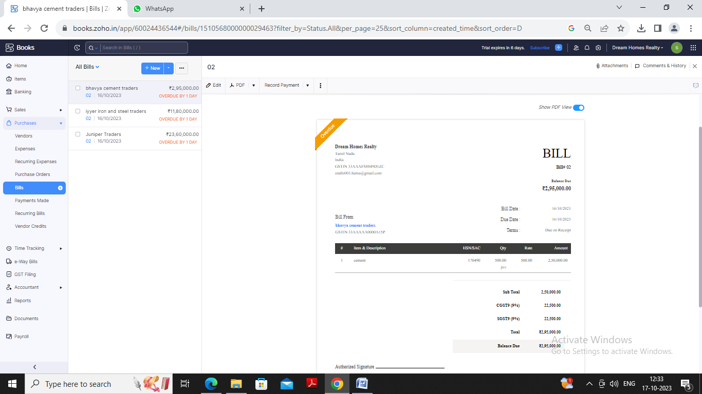**Bill:**

**Advantages Of Dream Homes Realty:**

* **Dream Homes is one of the best and reliable builders among all. As it is said people should not waste their hard earned money without thinking property investment related aspects.**
* **Dream homes property provided us good flat at a good price.. Our flat is full furnished and having good amenities with it.. Parking Space, play garden , near to markets and schools. So had a good deal with Dream home property..**
* **Dream homes realty in general is a good hedge against inflation, rental properties that are re-leased every year are especially effective, since monthly rents can be adjusted upward in inflationary periods.**

**Disadvantages Of Dream Homes Realty:**

* **When purchasing shares of a stock, the transaction cost for the trade is very low, often just a few dollars. But when purchasing dream homes property, the transaction costs are considerably higher.**
* **Unlike other types of investments, dream homes transaction costs can significantly affect the value of the investment and make it more difficult to turn a profit.**
* **Many investments are highly liquid, and can be bought and sold for a profit in a fraction of a second, as with high-frequency stock trading.**

**8.APPENDIX:**

[**https://github.com/Sruthinarmatha/dream-homes-realty_NM2023TMID22761?search=1\**](https://github.com/Sruthinarmatha/dream-homes-realty_NM2023TMID22761?search=1\)

|  |
| --- |
| <!DOCTYPE html> |
|  | <html lang="en" data-color-mode="auto" data-light-theme="light" data-dark-theme="dark" data-a11y-animated-images="system" data-a11y-link-underlines="false"> |
|  |  |
|  | <style> |
|  | /* for each iteration, uncomment the CSS variable */ |
|  |  |
|  | /* light themes */ |
|  | [data-color-mode="light"][data-light-theme*="light"], |
|  | [data-color-mode="auto"][data-light-theme*="light"] { |
|  | /* iteration 1 */ |
|  | --border-color-iteration-1: #C8CCD0; |
|  | /* iteration 2 */ |
|  | --border-color-iteration-2: #BABFC5; |
|  | /* iteration 3 */ |
|  | --border-color-iteration-3: #A6ADB4; |
|  | /* iteration final */ |
|  | --border-color-iteration-4: #868F99; |
|  |  |
|  | /* the first value is the final step, which falls back to previous iterations */ |
|  | --control-borderColor-rest: var(--border-color-iteration-4, var(--border-color-iteration-3, var(--border-color-iteration-2, var(--border-color-iteration-1)))) !important; |
|  | } |
|  |  |
|  | /* dark themes */ |
|  | [data-color-mode="dark"][data-dark-theme*="dark"], |
|  | [data-color-mode="auto"][data-light-theme*="dark"] { |
|  | /* iteration 1 */ |
|  | --border-color-iteration-1: #363940; |
|  | /* iteration 2 */ |
|  | --border-color-iteration-2: #3F434B; |
|  | /* iteration 3 */ |
|  | --border-color-iteration-3: #4B5159; |
|  | /* iteration final */ |
|  | --border-color-iteration-4: #666E79; |
|  |  |
|  | /* the first value is the final step, which falls back to previous iterations */ |
|  | --control-borderColor-rest: var(--border-color-iteration-4, var(--border-color-iteration-3, var(--border-color-iteration-2, var(--border-color-iteration-1)))) !important; |
|  | } |
|  |  |
|  | [data-color-mode="dark"][data-dark-theme="dark_dimmed"], |
|  | [data-color-mode="dark"][data-dark-theme="light_high_contrast"], |
|  | [data-color-mode="dark"][data-dark-theme="dark_high_contrast"], |
|  | [data-color-mode="light"][data-light-theme="dark_dimmed"], |
|  | [data-color-mode="light"][data-light-theme="light_high_contrast"], |
|  | [data-color-mode="light"][data-light-theme="dark_high_contrast"] { |
|  | /* skip these themes, use the fallback */ |
|  | --control-borderColor-rest: initial !important; |
|  | } |
|  |  |
|  | @media (prefers-color-scheme: dark) { |
|  | /* dark colors in dark mode */ |
|  | [data-color-mode="auto"][data-dark-theme*="dark"] { |
|  | /* iteration 1 */ |
|  | --border-color-iteration-1: #363940; |
|  | /* iteration 2 */ |
|  | --border-color-iteration-2: #3F434B; |
|  | /* iteration 3 */ |
|  | --border-color-iteration-3: #4B5159; |
|  | /* iteration final */ |
|  | --border-color-iteration-4: #666E79; |
|  |  |
|  | /* the first value is the final step, which falls back to previous iterations */ |
|  | --control-borderColor-rest: var(--border-color-iteration-4, var(--border-color-iteration-3, var(--border-color-iteration-2, var(--border-color-iteration-1)))) !important; |
|  | } |
|  |  |
|  | /* light colors in dark mode */ |
|  | [data-color-mode="auto"][data-dark-theme*="light"] { |
|  | /* iteration 1 */ |
|  | --border-color-iteration-1: #C8CCD0; |
|  | /* iteration 2 */ |
|  | --border-color-iteration-2: #BABFC5; |
|  | /* iteration 3 */ |
|  | --border-color-iteration-3: #A6ADB4; |
|  | /* iteration final */ |
|  | --border-color-iteration-4: #868F99; |